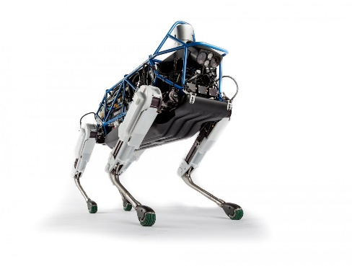SPOT, Boston Dynamics

In the between deliberative and reactive.

* Real time response
* Involve a lot of computation and variables to control movement
* Able to track object
* Able to move autonomously